The buildings did well in Hurricane Matthew, except for some flooding in the basement of the guest house. You can see the water line (five cinder blocks high) in the picture below.
Dear Haiti Supporter,
I am just back from a quick trip to help with a medical team doing Hurricane Matthew relief work. This is the latest picture of the clinic and school buildings. Although it was ‘rainy season’ it was pretty dry except for the residual flooding from the hurricane.
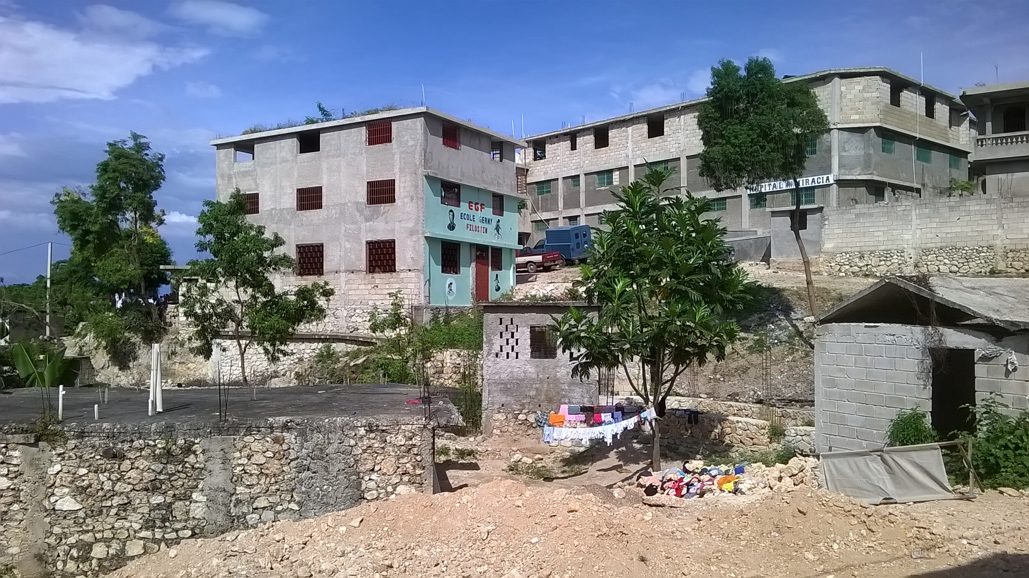
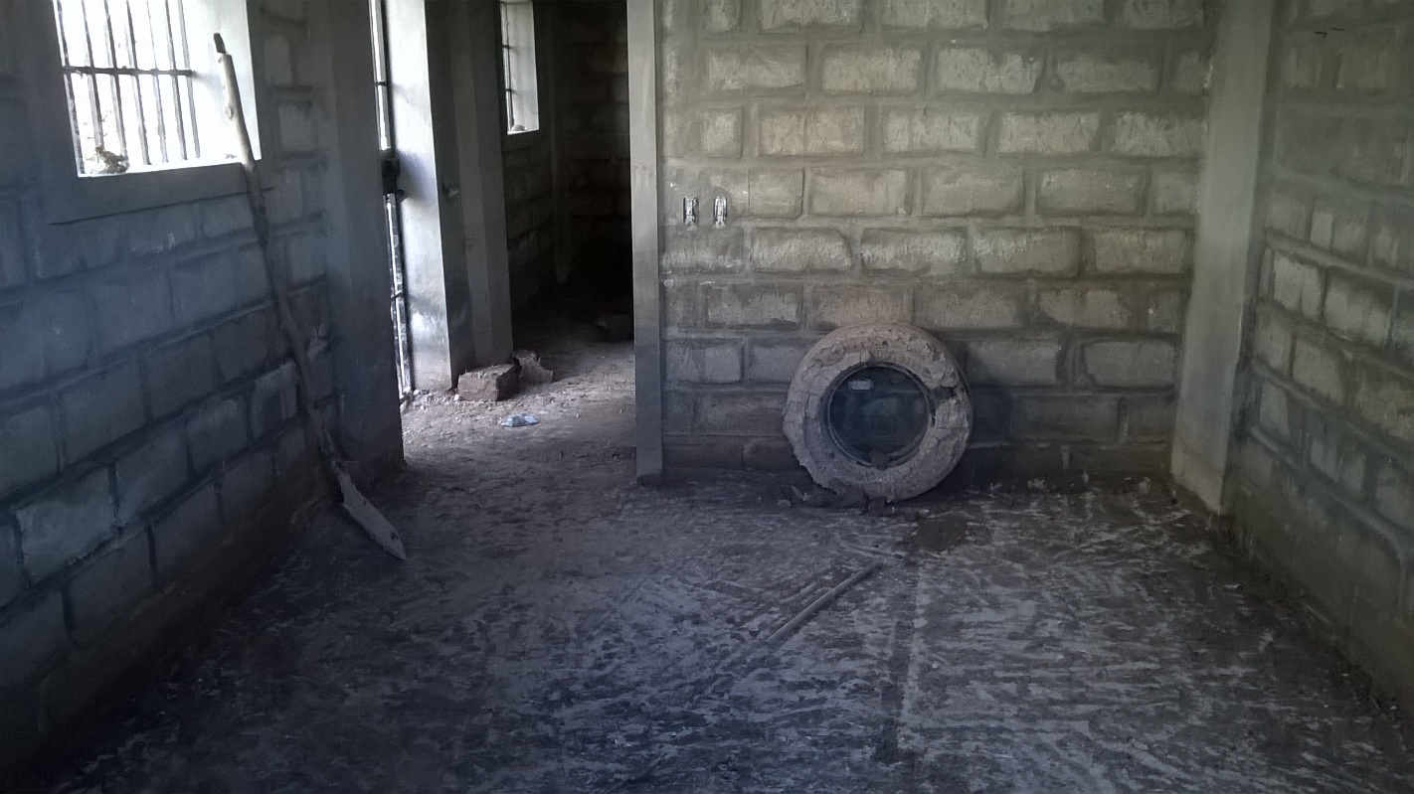
From November 10–17 the Institute of Grace sponsored clinics in the areas of Les Ceyes, Merigo, and Leogane. These areas suffered significant flooding and loss of property during the hurricane. The people were very appreciative of the clinic and medicines, all provided free of charge because of your donations.
The Medical Clinics featured Haitian Doctors and Nurses with assistance from an American pharmacist and other helpers. I got to help in the pharmacy as medicines were in great demand. The picture below is of the church in Ceyes were we held the Saturday clinic. Hundreds from the community turned out. You can see some of the storm damage. Some homes were leveled by the wind and rain. Others did surprisingly well.

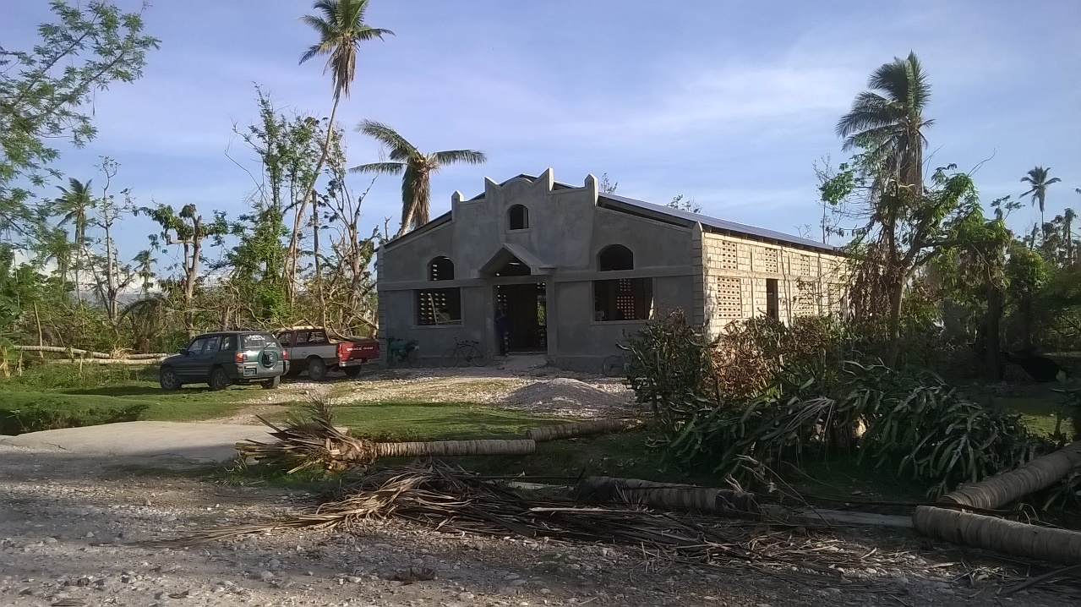
It was exciting to have Doctor Andrew leading the clinic effort.
Here he is in his clinic office in Delmas.
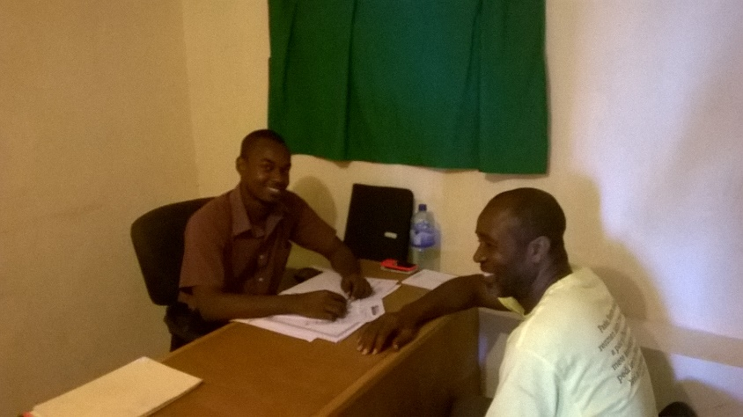
The work on the cistern continues in Merger:
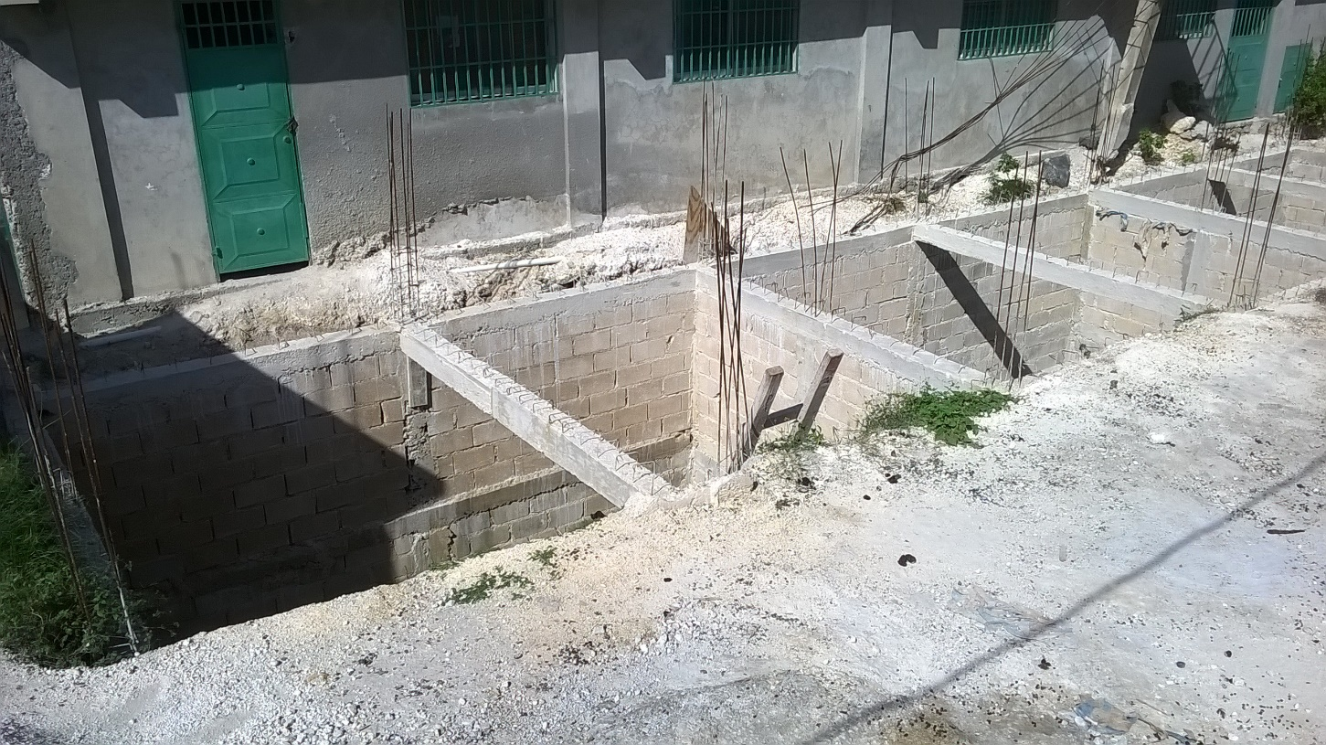
From this picture you can see that the walls of the new cistern have been bricked in and the concrete beams poured. The next steps are to ‘polish’ the walls and then pour the roof or top of the cistern. This has been a huge project but it will supply much needed water for the three buildings.
Ministry in Haiti brings many special challenges. Executive Director Jean Filostin was involved in a traffic accident with a very large truck in Carrefour. He was not hurt but our main pickup was significantly damaged. It is currently in the shop being repaired. Jean is in the green shirt. In the red shirt is Boss Eric, our primary driver and mechanic.
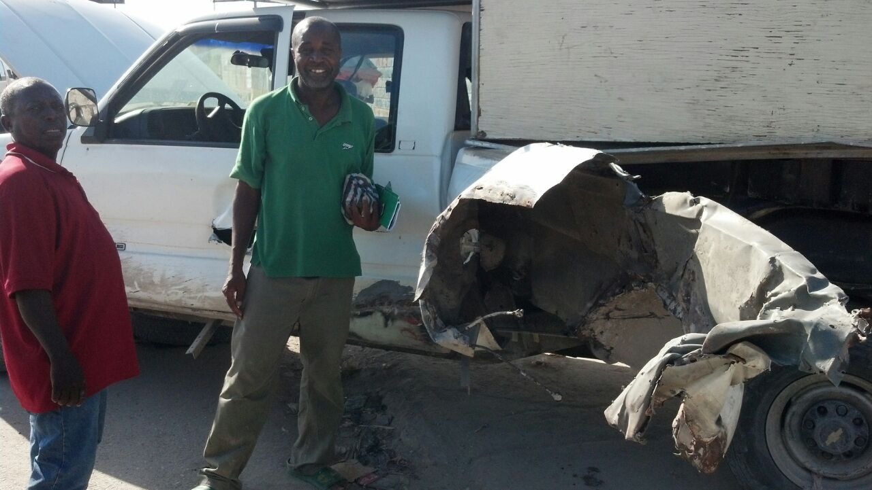
The work of the school continues. We were pleased to be able to include school supplies provided by the Iota Lambda Omega chapter of the Alpha Kappa Alpha Sorority in the Isuzu box truck we shipped in November. The truck is enroute but the special ordered backpacks provided by AKA will be going with us in January. Below we have some of their members delivering the supplies and some of our packing helpers as we packed up the box truck at Silver Spring UMC.
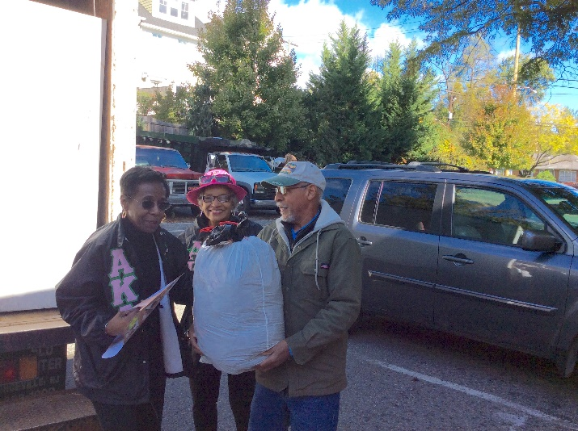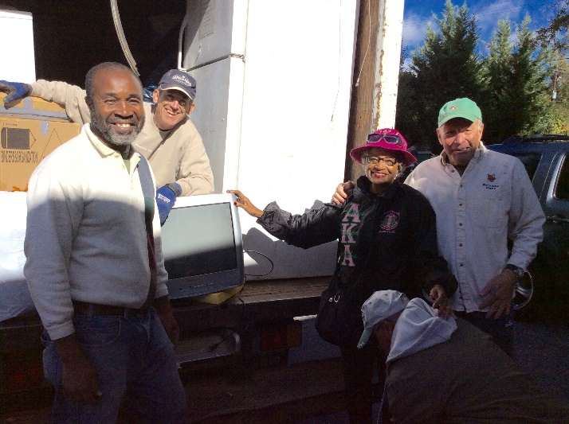
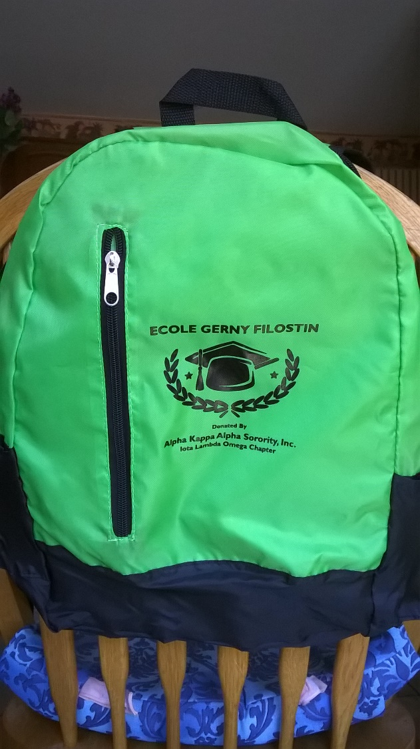
The truck has bags and bags of shoes and other supplies for the school and other projects. We are thankful for the churches that have gathered supplies and send donations to support these kids who would otherwise be wandering the streets during the school day. Our lunch program continues as well, as these children receive a nutritious hot meal each day, again thanks to the contributions of IOG supporters here in the U.S. The school opens their doors to every student they can, so the need for ongoing support is great. If you or your group would like to support a teacher or a classroom or contribute toward the daily expenses of running the school, please send your contributions to
The Institute of Grace,
P.O. Box 2364,
Leesburg, VA 20177
[These contributions are tax-deductible
and make a world of difference.]

It was great to see the children and staff in Merger, even for just a brief visit. I am looking forward to going back in January. Team members will have the opportunity to work directly with the children and also build the teaching skills that help the children all year long.
Give me a call or an email if you would like to be part of a team in 2017 or help fund the school or medical work.

Thanks for being part of the ongoing mission of helping Haitians learn and grow, physically and spiritually.
David Graves
240 601 0218.

The Institute of Grace
P. O. Box 2364
Leesburg, VA 20177
